GTANA, London Plan & Local plan update

GTANA and London Plan update
- There is no progress to report on the publication of the GTANA by the GLA.
- A ‘high level Statement of Intent’ is expected in April 2025 to inform the London Plan

Local Plan 2021 – 2036
The local plan was adopted by full cabinet on 4th March. Table of replacement Local Plan policies are provided against each reason for refusal (including those that have been withdrawn).

1 The development proposed is inappropriate development in the Green Belt and would result in material harm to openness. The very special circumstances advanced by the applicant(s) do not clearly outweigh the inappropriateness of the development and its potential harm to the Green Belt. As such the proposal is contrary to the National Planning Policy Framework (2023), Policy G2 of London Plan (2021), Policy CS7 of Barnet's Adopted Core Strategy (2012), and Policy DM15 of the Local Plan Development Management Policies DPD (2012).

2. The local planning authority does not consider based on the information provided with the application that the intended occupants of the site come within the definition of gypsies and travellers as set out in Annex 1: Glossary of the Planning Policy for Traveller Sites August, 2015, or that the personal circumstances of any of these intended occupants establishes very special circumstances that would outweigh harm to the Green Belt. As such the proposal is contrary to the National Planning Policy Framework (2023), policy G2 of London Plan (2021), policy CS7 of Barnet's Adopted Core Strategy (2012), and Policy DM15 of the Local Plan Development Management Policies DPD (2012).

Officer comments on replacement Local Plan policies (Planning)

National policy in the NPPF (2024 updated February 2025), and Core strategy Policy CS7 and Development Management Policy DM15 seek to resist inappropriate development in the Green Belt and protect openness.

Adopted local plan policy ECC06 Green belt states that any development in the Green Belt ‘will be considered in accordance with the NPPF’

Both the Planning proof of evidence and rebuttal statement fully assesses the application in accordance with the current NPPF

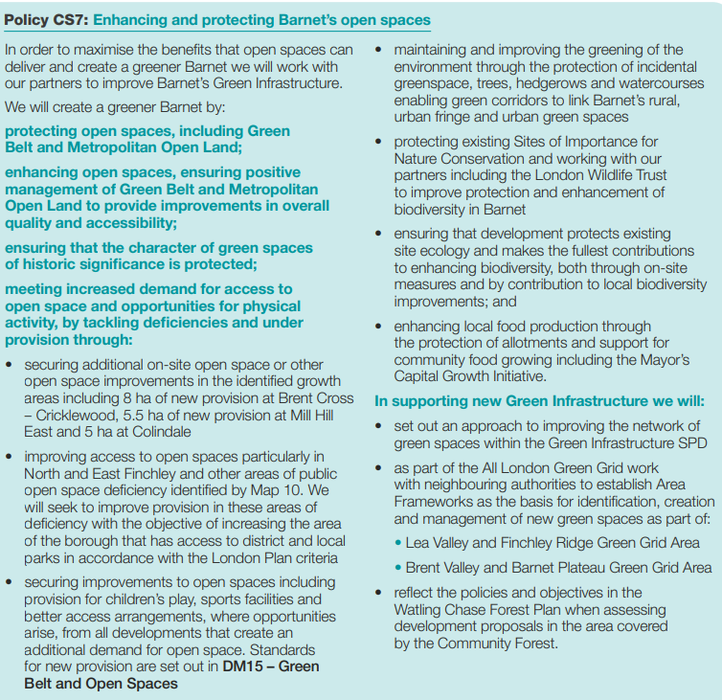 | 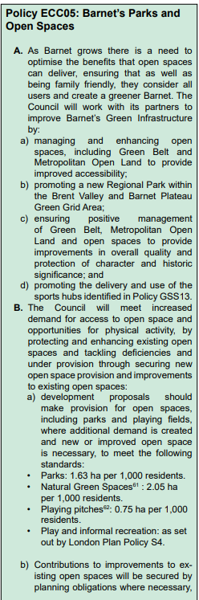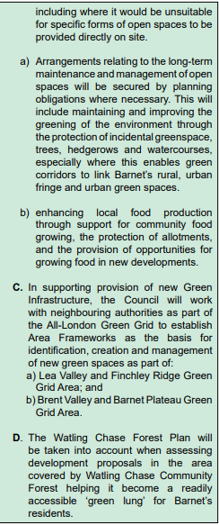
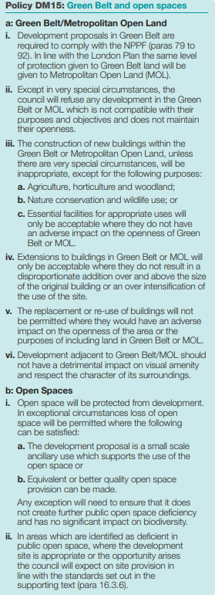 | 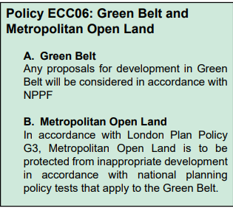

3. The proposed development will result in an increase in built form on a site that has not been previously developed and will result in a use of greater intensity. Such a use is at odds with the prevailing characteristics of the immediate and wider area and would result in harm to the character and appearance of this site contrary to the National Planning Policy Framework (2023), policies D1, D4 and D5 of London Plan (2021), Policies CS4 and CS5 of Barnet's Adopted Core Strategy (2012), Policy DM01 of the Local Plan Development Management Policies DPD (2012) and emerging local plan policy HOU07

Officer comments on replacement Local Plan policies (Planning)

Policy CS4 required the scale of any site to align with the local context and character. Policy CS5 sought to ensure that developments in Barnet respect the local context and distinctive character, creating high-quality places and buildings. Development Management Policy DM01 specified that all developments should achieve high-quality design and demonstrate significant environmental awareness. The replacement policies HOU02, HOU06 (formerly HOU07), and CDH01 maintain consistent objectives, seeking to secure high-quality design by ensuring developments respond sensitively to the distinctive local character, design, building form, development patterns, scale, massing, roof form, and height of the existing context. Additionally, the use of materials must be of suitable quality and appearance to respect the local character and setting.

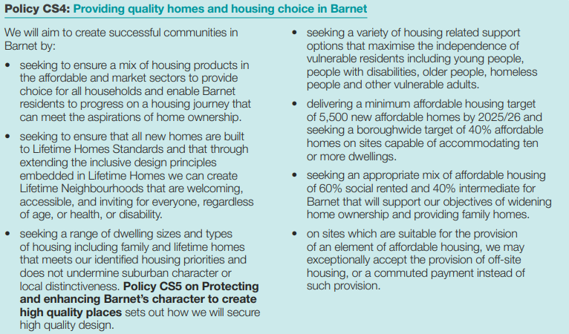  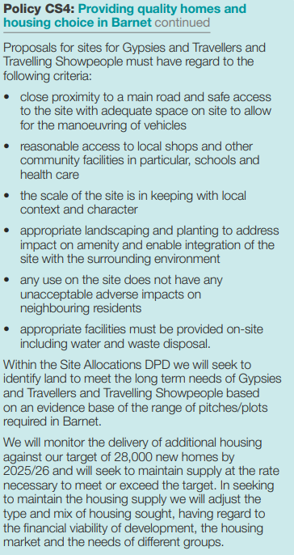  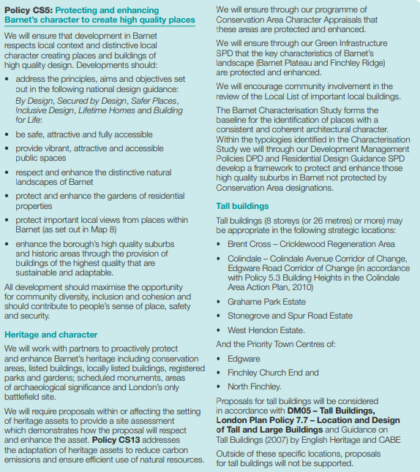  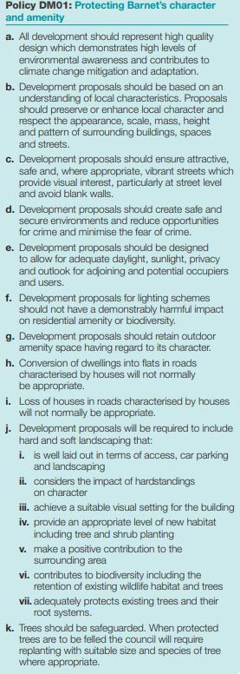 | 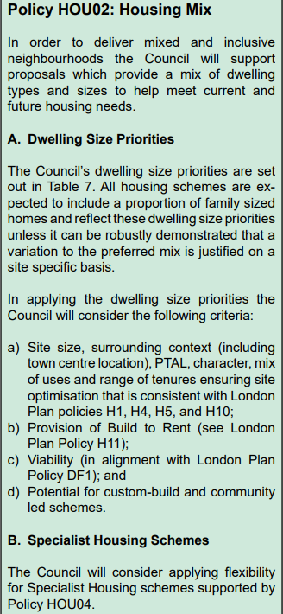  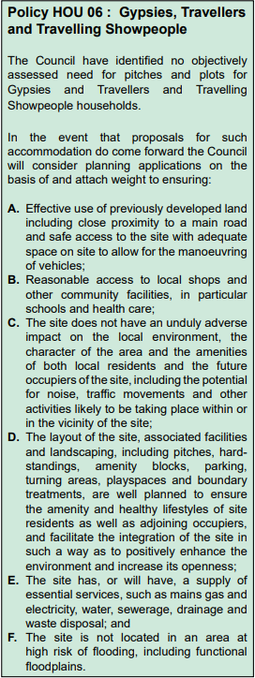  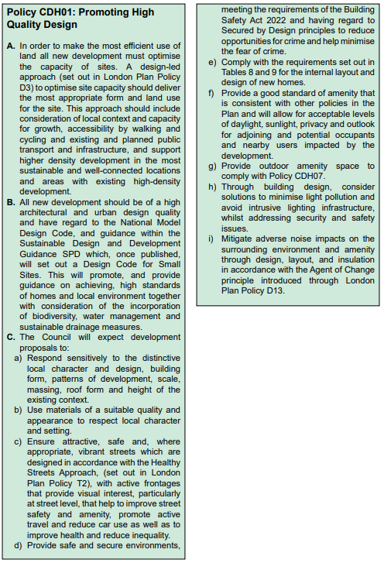  As Above

4. In the absence of eDNA testing (and potentially further traditional GCN surveys) it has not been demonstrated that the proposed development would mitigate against the disturbance of great crested newts and their foraging/sheltering habitats within 500 metres of the application site contrary to the National Planning Policy Framework (2023), Policy G6 of the London Plan (2021), Policies DM01 and DM16 of the Local Plan Development Management Policies DPD (2012) and emerging local plan policy ECC07

Officer comments on replacement Local Plan policies (Ecology)
Barnet’s new local plan policy ECC07 strengthens the reason for refusal on ecology grounds. Previously Barnet Local Plan policy DM16 required the council to seek the retention, enhancement and creation of biodiversity when considering a development. Development Management Policy DM01 specified that all developments should achieve high-quality design and demonstrate significant environmental awareness. The replacement policy ECC07 requires the same considerations for biodiversity within an application but with specific reference to various evaluation criteria including safeguarding of designated site, priority habitats and species [including European Protected Species] in accordance with the NERC Act 2006. The policy states explicitly that where unacceptable harm cannot be avoided, adequately mitigated or at a last resort compensated then the application [under review] will be refused.

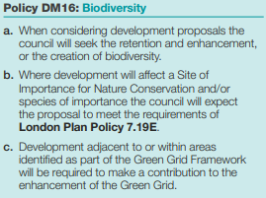 | 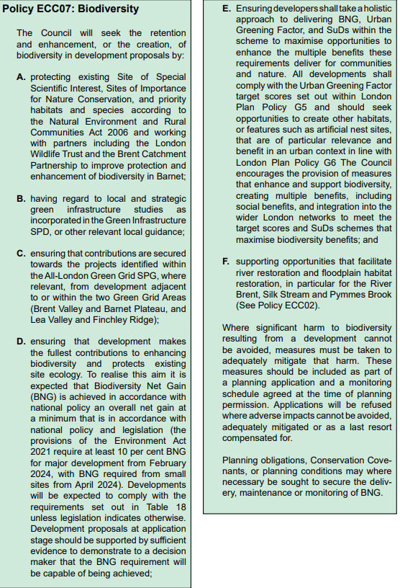

5 In the absence of detailed tree protection measures indicating site levels and the protection and enhancement of existing protected trees in and around the application site it has not been demonstrated that the trees would be protected during the course of the proposed development. Therefore, the proposal is not considered to safeguard the health of existing tree(s) which provide significant public amenity and are integral to the character of the Green Belt and Barnet's urban fringe contrary to the National Planning Policy Framework (2023), Policy G7 of the London Plan (2021), Policies CS4, CS5 and CS7 of Barnet's Adopted Core Strategy (2012), Policy DM01 of the Local Plan Development Management Policies DPD (2012) and emerging local plan policy HOU07.
Officer comments on replacement Local Plan policies (Trees)

Policies HOU06 (formerly HOU07), CDH01, ECC05 and ECC07, maintain the requirement to consider biodiversity including need to demonstrate that development does not impact on trees and any identified impact is adequately mitigated for.

6 In the absence of a flood risk assessment and surface water drainage strategy it has not been demonstrated that this highly vulnerable form of development would be protected from potential sources including but not limited to surface water, groundwater, sewer, and artificial sources. The strategy also needs to confirm the appropriateness of the proposed soakaway in relation to adversely affecting surface water runoff and potential flood risk. In the absence of such, the proposal is contrary to the National Planning Policy Framework (2023), Policies SI 12 and SI 13 of the London Plan (2021), Policy CS13 of Barnet's Adopted Core Strategy (2012), Policy DM01 of the Local Plan Development Management Policies DPD (2012) and emerging local plan policy HOU07
Officer comments on replacement Local Plan policies (Flooding)
Policies ECC03 and HOU06 (formerly HOU07) refer to the need to consider flood risk and sustainable drainage.
For policy ECC03 (Flood Risk) the Council will seek to ensure:
d) A site specific Flood Risk Assessment is undertaken in consultation with the Environment Agency (if applicable) or Lead Local Flood Authority if it is:
iii) A non-householder application on a site within 1 per cent AEP (Annual Exceedance Probability) plus 70 per cent climate change fluvial flood extent and/or the 0.1 per cent AEP RoFSW (Risk of Flooding from Surface Water) flood extent.

Mapping from West London Strategic Flood Risk Assessment
River Brent 1 in 100 plus 70 per cent climate change fluvial flood extent – No impact
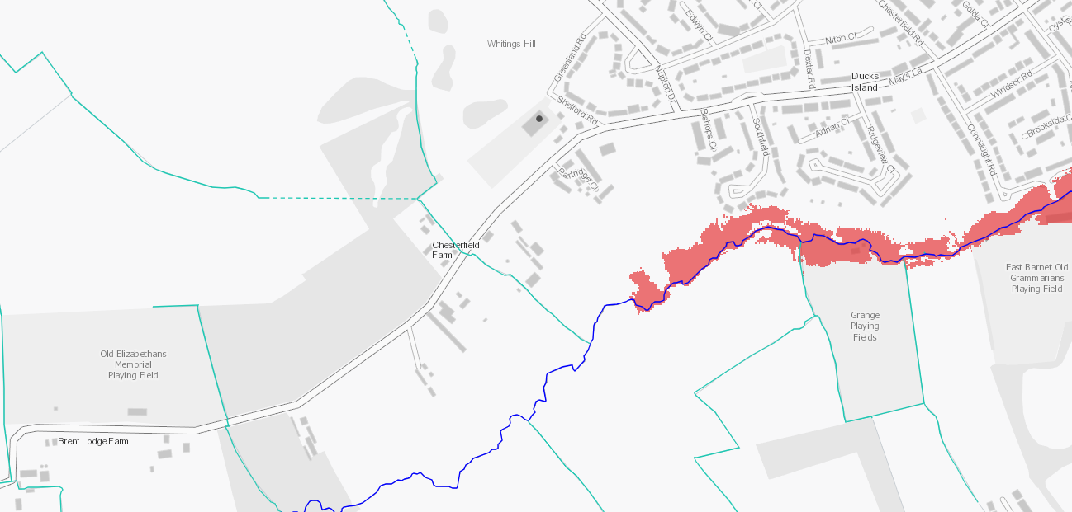

Surface Water Flooding map

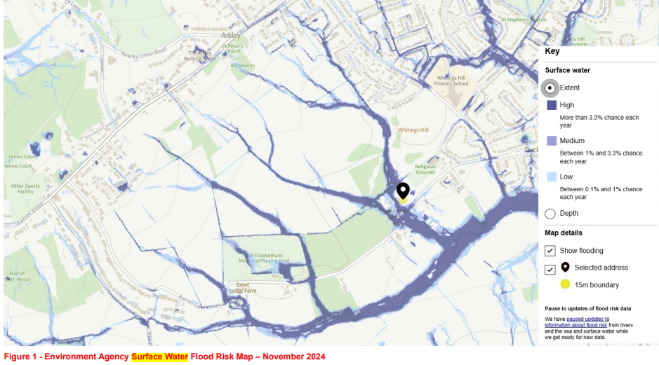

‘Medium Risk’ (Between 1% and 3.3% chance of flooding, each year). Refer to Councils response to Inspectors flooding questions document ID13).

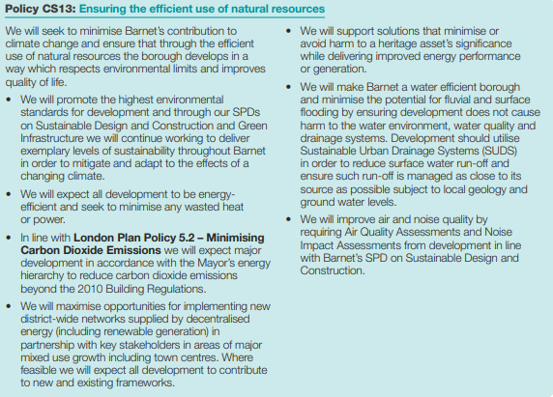 | 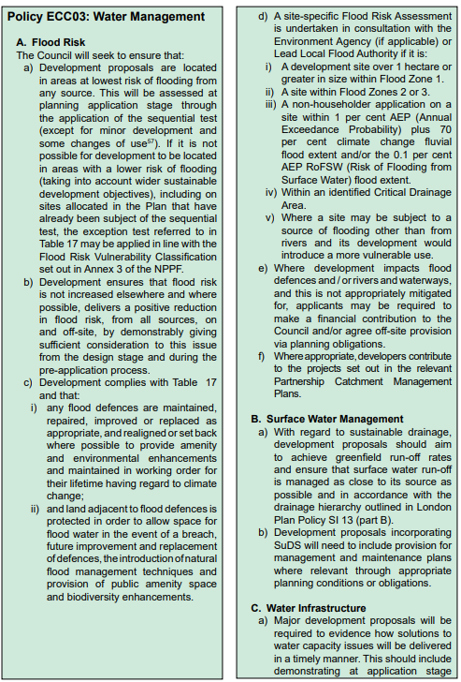
 | 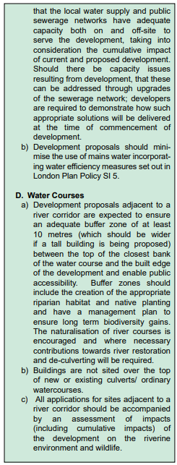

7 In the absence of a transport statement, including swept path analysis and highway mitigation measures, it has not been demonstrated that vehicles can safely access and egress the application site without causing detrimental harm to highway and pedestrian safety and the free-flow of traffic along Mays Lane, contrary to Policies CS4 and CS9 of the Local Plan Core Strategy DPD (2012), Policy DM17 of the Local Plan Development Management Policies DPD (2012) and emerging local plan policy HOU07.

Officer comments on replacement Local Plan policies (Transport)

Policy TRC01 (Sustainable and Active Travel) and Policy TRC03 (Parking Management) replace policies CS9 and DM17 and policy HOU06 (formerly HOU07) replaces CS4.

The above policies seek to improve the ability of people and goods to move around the Borough safely and efficiently which is vital for its continued social and economic wellbeing. Environmental wellbeing will also be achieved through less congestion and the promotion of modal shifts in transport, for instance from private vehicles to more sustainable forms of transport. Policies TRC01 and TRC03 place a burden on the development to be policy compliant by promoting development that will not have a detrimental impact on the local highway network, congestion, pedestrian and air pollution. For example, upgrading the site access will make it safer and easier for vehicles to enter and exit the site and ensure that adequate visibility splays are maintained on both sides of the access.

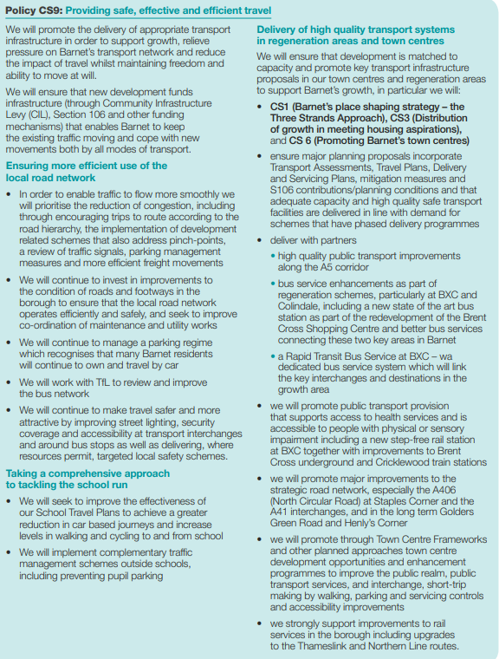  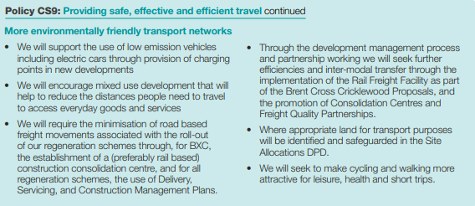 | 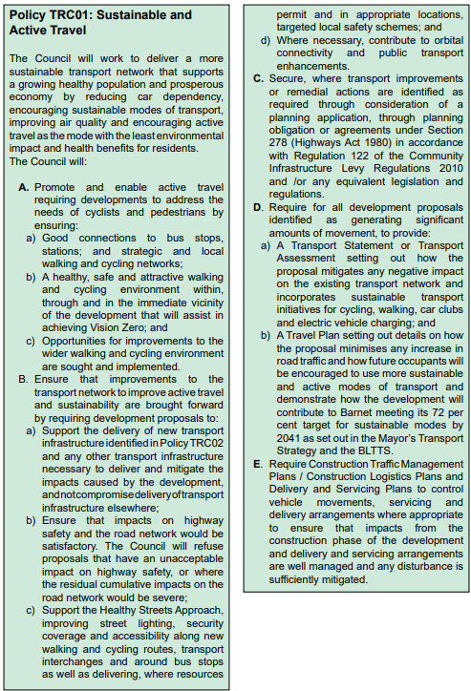

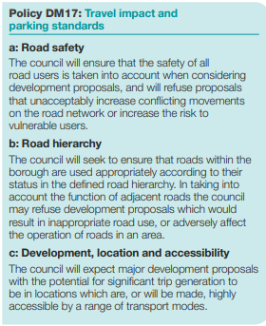  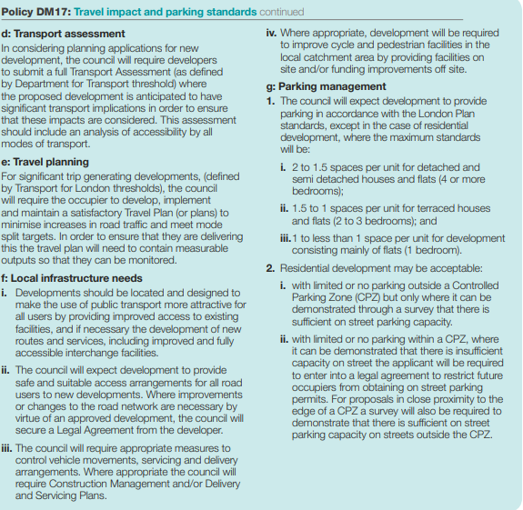 | 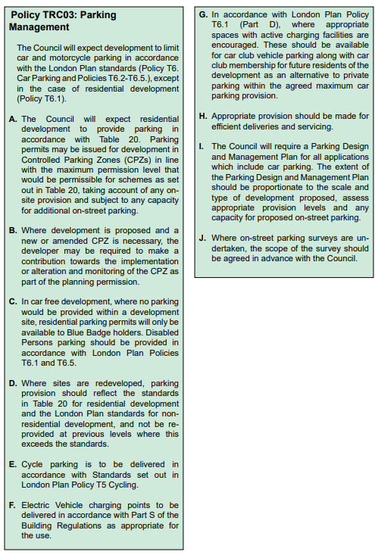

FULL Cabinet 4th March
https://barnet.moderngov.co.uk/documents/s88468/Appendix%20D%20-%20Barnet%20Local%20Plan%202021%20-2036%20280125%201-compressed.pdf
https://barnet.moderngov.co.uk/ieListDocuments.aspx?CId=162&MId=11603&Ver=4

