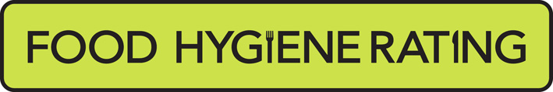  Food Hygiene Rating Scheme  ‘Right to reply’ | 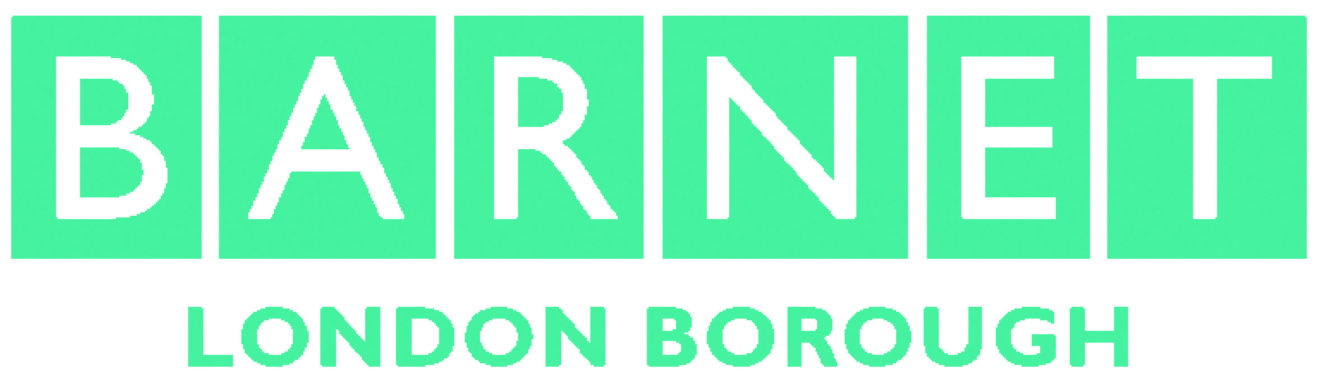 | 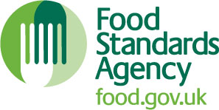

Notes for businesses:

- As the food business operator of the establishment you have a ‘right to reply’ in respect of the food hygiene rating given following your inspection.
- The purpose is to enable you to give an explanation of subsequent actions that have been taken to make the required improvements as detailed in the inspection letter, or to explain mitigation for the circumstances at the time of the inspection. It is not for making complaints or for criticising the scheme or food safety officer.
- If you wish to use this ‘right to reply’, please use this form and return it to the Food Team at the address below.
- Your comments will be reviewed by the food safety officer and may be edited for clarity or to remove offensive or defamatory remarks before being published online and displayed together with your food hygiene rating at food.gov.uk/ratings. Where we change the wording for clarity, we will send you a copy to ensure that it accurately reflects your comments.
- There will be a statement at food.gov.uk/ratings that will highlight that the accuracy of your comments has not been verified by local authority officers. You can send a right to reply form to us at any time, and we will upload it onto the web site unless it is sent in after we have completed the next routine inspection and a new rating then applies.

Business details
Food business operator/proprietor

Business name

Business addresses

Inspection details
Date of inspection |  |  |  |  | Food hygiene rating given

Comments
I agree with the inspection results but have since carried out the following improvements (tick all that apply):
The establishment has been thoroughly cleaned and procedures are in place to ensure that cleanliness is maintained.
The establishment has been or will shortly be fully renovated.
A new management system has been implemented.
There is now a new manager and/or new staff.
The staff have been trained/re-trained/given instruction/are under revised supervisory arrangements.
Other – please specify below.
The conditions found at the time of the inspection were not typical of the normal conditions maintained at the establishment and arose because (Please explain below and use only the space provided. You can also state any other improvements made):
Signature
Name in capitals

Position |  | Date
If you would like any assistance completing this form, please contact the food team at foodsafety@barnet.gov.uk.
Please now return this form to:
Food, Health and Safety Team,
London Borough of Barnet,
Barnet House, 9th Floor,
1255 High Road, Whetstone, N20 0EJ

How your information will be used

Barnet Council will collect and use the information you give us to undertake our functions as a local authority and deliver services to you. It is our responsibility to ensure that your information is kept safe. Where necessary and legally allowed, we will share your information with trusted external organisations, commissioned partners and contracted service providers in order to deliver services and support to you.

The information we collect may be used to better understand your use of our services and assist us in improving our services. This is to ensure we are using public funds in the best possible way. Under our duty to protect public money we may use the information you have provided for the prevention and detection of crime.
For further details of how we use your information and to understand your rights please visit www.barnet.gov.uk/privacy or email data.protection@barnet.gov.uk to request a full copy of our privacy notice.

