Scheme Name: Corner Mead, Saracens School
Our Ref.: RSW020
Department: Environment directorate - Highways
Date: 9 January 2025
Contact Details: Highways Service
Tel. 020 8359 3555
HighwaysCorrespondence@Barnet.gov.uk

Dear Sir/Madam,
We are writing to you as part of the Councils statutory consultation process to seek your views on our proposal to introduce new measures on Corner Mead, next to Saracens School. The proposals aim to improve safety for all road users, and in particular pedestrians.

The proposals incorporate the following engineering measures which are shown on the attached plan:

- Introduce a 20mph zone on Corner Mead with the aim of improving safety, especially for children.
- Upgrading the existing uncontrolled crossing near Long Mead to zebra crossing, providing a safer crossing point near Saracens Schools, where pedestrians would have priority.
- Redesign the Corner Mead junction with Withers Mead, making the junction safer for pedestrians crossing.
- Widening the footway near bus stop QK, to increase capacity at the bus stop waiting area.
We are also proposing to make changes to the existing parking layout. The aim of these proposals is to improve visibility, allow for footway improvements, and to ensure sufficient space is available for larger vehicle manoeuvres.

- Removing approximately 15m of resident parking bay (CL2 Mon-Fri 9am-4pm) located at Corner Mead next to bus stop QP.
- Existing double yellow lines to be replaced by zig-zag lines for approximately 57.2m around the proposed zebra crossing.
- Existing no stopping on school entrance (Mon-Fri 8am-5.30pm) markings to be reduced in length to 41.5m to accommodate the proposed zebra crossing zig-zag markings.
The proposals are illustrated on the enclosed drawing RSW020 Saracens School _SC-100-01.

This letter is being sent to you as part of the council’s statutory consultation process for the proposals outlined above. The proposals are also being advertised in the Barnet Times and the London Gazette on 9 January 2025 and notices are also being put up in the area advising of the proposed changes.

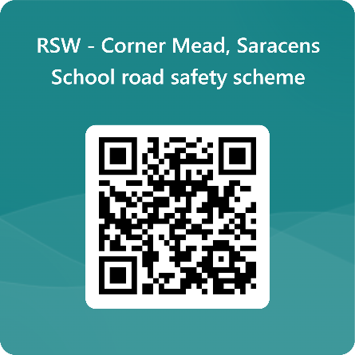
We want to hear from you

The consultation period commences on 9 January 2025. You can have your say on our proposals by completing our online questionnaire by scanning the QR code below.

Alternatively, the questionnaire can be viewed here: https://forms.office.com/e/tJCA9BmtAA

The closing date for the consultation is 6 February 2025.

If you are unable to complete the questionnaire online and would like to request a paper copy, please call Highways Correspondence section on 020 8359 3555 or email HighwaysCorrespondence@Barnet.gov.uk, quoting reference number RSW020.

Following the consultation close date, officers will review all feedback received and provide recommendations whether to progress the scheme, with or without modification, or not to progress. We will write to residents again ahead of implementing any final scheme.

Yours faithfully,
Highways Service.

